**How-To: Make a Career Services Appointment**

**Step 1:**

Go to the Student Portal in Slate

**Your Name**

CWID | Major

**Step 2:**

Click on the “Services” tab and Select Career Services. This will take you to the Career Services Home Page.

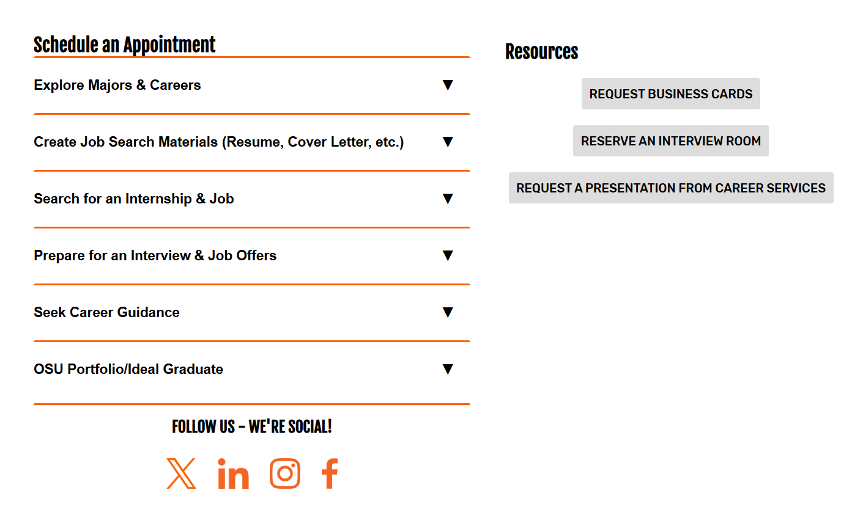

**Step 3:**

Select the type of appointment you want, and you will be directed to you Career Coach’s Appointment Calendar.

To view additional Career Coaches from other areas, you can scroll down to the bottom of the page.